**FLAPPY BIRD GAME**

Submitted in partial fulfillment of requirements

For the degree of

Diploma

by

**DHRUV KARIA FCOG19117**

**YASH CHAUHAN FCOG19107**

**DEVANG DEDHIA FCOG19109**

**TAHA SHAIKH FCOG19150**

Guide

**Dr. S.G. Kolte**



**Department of Computer Engineering**

**K. J. Somaiya Polytechnic, Mumbai-77**

**Batch 20-20**

**Certificate**

This is to certify that the Dissertation entitled **“*Flappy Bird Game”*** is bonafide record of the dissertation work done by ***Dhruv Karia, Yash Chauhan, Devang Dedhia, Taha Shaikh*** in the year **2021-22** under the guidance of “***Dr. S.G Kolte”*** of Department of Computer Engineering in partial fulfillment of requirement for the Diploma degree in Computer Engineering.

_________________ _____________________

**Guide-** **Head of the Department-**

**Dr. S.G. Kolte Dr. S.G. Kolte**

_________________

**Principal-**

**Padmaja B. Bandaru**

Date: 25/12/2021

Place: Mumbai-77

**K. J. Somaiya Polytechnic, Mumbai-77**

**Certificate of Approval of Examiners**

We certify that this project report entitled **“*Flappy Bird Game”*** is bona fide record of project work done by ***Dhruv Karia, Yash Chauhan, Devang Dedhia, Taha Shaikh*.**

This project is approved for the award of Diploma Degree in Computer Engineering.

_________________ _________________

External Examiner Internal Examiner

Date:

Place: Mumbai-77

**ACKNOWLEDGEMENTS**

In the accomplishment of this project successfully, many people have bestowed upon us their blessings and the heart pledged support, this time we are utilizing to thank all the people who have been concerned with the project.

We would like to express our special gratitude to our guide **“*Dr. S.G Kolte”***, who gave us the opportunity to implement this Project of course on ***“Flappy Bird Game”*** and contributed in stimulating suggestions, honest reviews, encouragement and also for resolving errors, helping us to coordinate our project. This project has helped us to get enlightened and learn about various methodologies, provide us with real- world team building and co-working experiences.

Lastly, we would like to thank our all the Teachers and our Principal Ma’am ***“Padmaja B. Bandaru”*** for her help by providing us with the necessary resources which served as the most important contribution towards the completion of the project and providing this opportunity of Industrial Training for all the students. We would also like to thank our parents and friends who helped us a lot in finalizing this project within the limited time frame.

**Abstract**

**“Flappy Bird Game”** We all are familiar with this game. In this game, the main objective of the player is to gain the maximum points by defending the bird from hurdles.

The preparations required for the graphics and audio are similar. First the image and audio files had to be searched for online. Once we agreed on the images and audio for the game, we edited them to fit our game design. Finally, both the image and audio files had to be converted to MIF format in order to be stored in the on-chip ROM blocks.

We will be using Pygame(a Python library) to create this Flappy Bird game. **Pygame** is an open-source library that is designed for making video games. it helps us to create fully functional games and multimedia programs in python.

**Contents**

|  |  |  |  |  |
| --- | --- | --- | --- | --- |
| **List of Figures**…………………………………………………………………………….. | | | | Viii |
| **List of Tables**……………………………………………………………………………… | | | | Ix |
| **Nomenclature**…………………………………………………………………………....... | | | | X |
| **1** | **Introduction**……………………………………………………………………... | | | 1 |
| **2** | **Literature Survey**………………………………………………………………. | | | 6 |
| **3** | **Project Name** ………………………………………………………………… | | | 9 |
|  | 3.1 | | Introduction………………………………………………………………. | 9 |
|  | 3.2 | | Design……………………………………………………………… | 9 |
|  | 3.3 | | Technologies Used…………………………………………………. | 13 |
|  |  | |  |  |
| **4** | **Implementation** ……………………………………………. | | | 28 |
| **5** | **Result & Analysis** | | |  |
| **6** | **Conclusions and Scope for future work**……………………………………… | | | 55 |
|  | 6.1 | Conclusions………………………………………………………………. | | 55 |
|  | 6.2 | Scope for Future Work……………………………………………………. | | 56 |
| **References** ……………………………………………………………………………... | | | | 57 |
| **Acknowledgements**………………………………………………………………………. | | | |  |

**List of Tables:**

|  |  |
| --- | --- |
| **Table.no.** | **Table Name** |
| 1 | Literature Survey |
|  |  |
| 2 | Comparison Analysis of different models |
|  |  |

**Chapter 1**

**Introduction**

This chapter presents the overall summary of the project. This includes the project problem statement, idea and motivation behind the project and also basic information technologies used in the project.…….

**“Flappy Bird Game”** We all are familiar with this game. In this game, the main objective of the player is to gain the maximum points by defending the bird from hurdles.

The game was designed and built by Dong Nguyen, a developer who lives in Vietnam. Flappy bird is a side-scroller game where the player controls a bird, attempting to fly between columns of green pipes. The bird will be flying until it collisions with a pipe or it fall on ground. It’s a simple game of infinite level type. It’s a challenging game for all.

#### IDEA BEHIND THE PROJECT

* We choose game for our first software project. Actually, game is entertaining for anybody and in leisure time we can spend our time nicely by playing game. The flappy bird game implemented for only desktop.
* **Targets all Smartphone Users**– Because of the application’s simple content, it applies to all demographics, regardless of age, race, or gender. This application is free of any bias or reservations; it is a simple, universally accepted concept lacking any negative connotations. This application brings no shock, controversy, or need for questioning. There is truly no motive besides keeping the bird alive, a simple goal that anyone can appreciate.
* **Simplicity**– Flappy Bird is simple in appearance, concept, and execution. Learning and understanding the game takes little time and needs no prior context. Understanding the basics takes only seconds, which is fitting for a society that appreciates and gravitates toward concepts that are quick enough to hold a short attention span.

#### HYPOTHESIS

Is flappy bird game easy? Does flappy bird game give consistent scores?

Does flappy bird lead to anxiety?

**Chapter 2**

**LITERATURE SURVEY**

**This chapter presents background research for Flappy Bird Game.**

The aim of this paper is to develop and study an artificial intelligence based game-playing agent using genetic algorithm and neural networks. We first create an agent which learns how to optimally play the famous “Flappy Bird” game by safely dodging all the barriers and flapping its way through them and then study the effect of changing various parameters like number of neurons on the hidden layer, gravity, speed, gap between trees has on the learning process. The gameplay was divided into two level of difficulty to facilitate study on the learning process. Phaser Framework was used to facilitate HTML5 programming for introducing real-life factors like gravity, collision and Synaptic Neural Network library was used to implement neural network so as to avoid creating a neural network from scratch. Machine Learning Algorithm which we have adopted in this project is based on the concept of Neuro-Evolution and this form of machine learning uses algorithms which can evolve and mature over time such as a genetic algorithm to train artificial neural networks.

**2.1**

**Survey:**

Upon learning a bit about the game, just 3% of those who haven’t already downloaded Flappy Bird said they would definitely be interested in doing so if it came back to app stores. 14% said they would probably be interested in playing Flappy Bird. 36% said they would probably not be interested. 20% said they would definitely not be interested. And 27% don’t have a phone or mobile device that can download games.

**Chapter 3**

**This chapter presents the overall summary of the project.**

**3.1**

**Design:**

**Package Name:** flappyBird

**Classes:**

1. HomePage

2. MenuPanel

3. GamePanel

4. GameFrame

5. MainBird

6. BirdImage

7. WallImage

8. About

9. Help

10. MenuPage

11. Settings

**3.2**

**Technologies Used:**

* **Python:**

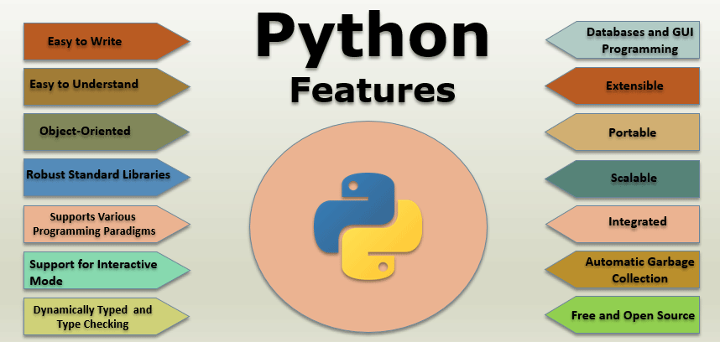

Python is an interpreted high-level general-purpose programming language. Its design philosophy emphasizes code readability with its use of significant indentation. Its language constructs as well as its object-oriented approach aim to help programmers write clear, logical code for small and large-scale projects. Python is dynamically-typed and garbage-collected. It supports multiple programming paradigms, including structured (particularly, procedural), object-oriented and functional programming. It is often described as a "batteries included" language due to its comprehensive standard library. Guido van Rossum began working on Python in the late 1980s, as a successor to the ABC programming language, and first released it in 1991 as Python 0.9.0.[34] Python 2.0 was released in 2000 and introduced new features, such as list comprehensions and a cycle-detecting garbage collection system (in addition to reference counting). Python 3.0 was released in 2008 and was a major revision of the language that is not completely backward-compatible. Python 2 was discontinued with version 2.7.18 in 2020. Python consistently ranks as one of the most popular programming languages.

### Python Features:

1. **Easy to Write**

These days with the increasing number of libraries in the languages, most of the time of developer goes in remembering them. This is one of the great features of python as python libraries use simple English phrases as its keywords. Thus, it’s very easy to write code in python. For e.g.:- Writing code for function doesn’t use curly braces to delimit blocks of code. One can indent code under a function, loop, or class.

1. **Easy to Understand**

This is the most powerful feature of the python language, which makes it everyone’s choice. As the keyword used here are simple English phrases; thus, it is very easy to understand.

1. **Object-Oriented**

Python has all features of an object-oriented language [such as inheritance,](https://www.educba.com/inheritance-in-python/) method overriding, objects, etc. Thus, it supports all the paradigms and has corresponding functions in their libraries. It also supports the implementation of multiple inheritances, unlike java.

1. **Robust Standard Libraries**

The libraries of python are very vast that include various modules and functions that support various operations working in various data types [such as regular expressions](https://www.educba.com/regular-expressions-in-java/) etc.

1. **Supports Various Programming Paradigms**

With support to all the features of an object-oriented language, Python also supports the procedure-oriented paradigm. It supports [multiple inheritances](https://www.educba.com/multiple-inheritance-in-python/) as well. This is all possible due to its large and robust libraries that contain functions for everything.

1. **Support for Interactive Mode**

Python also has support for working in interactive mode where one can easily debug the code and unit test it lines by line. This helps to reduce errors as much as possible.

1. **Automatic Garbage Collection**

Python also initiates automatic garbage collection for great memory and performance management. Due to this, memory can be utilized to its maximum, thus making the application more robust.

1. **Dynamically Typed and Type Checking**

This is one of the great feature of python that one need not declare the data type of a variable before using it. Once the value is assigned to a variable, its datatype gets defined. Thus, type checking in python is done at a run time, unlike other programming languages.

For e.g.-

v=7;// here type or variable v is treated as an integer v="great";//here type of the variable v is treated as a string

1. **Databases**

The database of an application is one of the crucial parts that also need to be supported by the corresponding programming language being used. Python supports all the major databases that can be used in an application, such as MYSQL, ORACLE, etc. Corresponding functions for their database operations have already been defined in python libraries. one needs to include those files in code to use it.

1. **GUI Programming**

Python [being a scripting language](https://www.educba.com/python-scripting-language/) also supports many features and libraries that allow graphical development of the applications. In the vast libraries and functions, corresponding system calls and procedures are defined to call the particular OS calls to develop an application’s perfect GUI. Python also needs a framework to be used to create such a GUI. Examples of some of the frameworks are Django, Tkinter, etc.

1. **Extensible**

This feature makes use of other languages in python code possible. This means python code can be extended to other languages as well; thus, it can easily be embedded in existing code to make it more robust and enhance its features. Other languages can be used to compile our python code.

1. **Portable**

A programming language is portable if it allows us to code once and runs anywhere. This means the platform where it has been coded and where it is going to run need not be the same. This feature allows one of the most valuable features of object-oriented languages- reusability. As a developer, one needs to code the solution and generated its byte code and need not worry about the environment where it will run. EO-one can run a code developed on the Windows operating system on any other operating system Linux, Unix, etc.

1. **Scalable**

This Language helps develop various systems or applications capable of handling a dynamically increasing amount of work. These types of applications help a lot in the organisation’s growth as they are strong enough to handle the changes upto some extent

1. **Free and Open Source**

Yes, u read it correctly u need not pay a single penny to use this language in your application. One needs just to download it from its official website, and it’s all done to start. And as it is open-source, its source code has also been made public. One can easily download it and use it as required as well as share it with others. Thus it gets improved every day.

1. **Integrated**

Python can be easily integrated with other available programming languages such as C, C++, Java, etc. This allows everyone to use it to enhance the functionality of existing applications and make them more robust.

**Chapter 4**

**IMPLEMENTATION**

**This chapter includes the overall working of project…**

1. **Importing:**

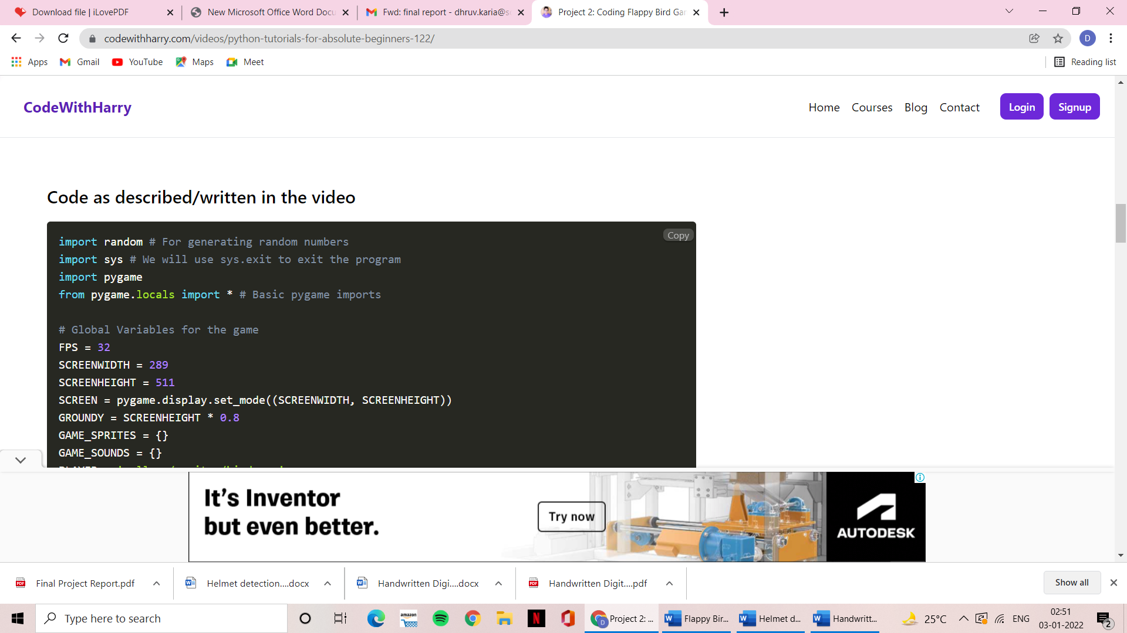

1. **Providing Global variables to the game:**

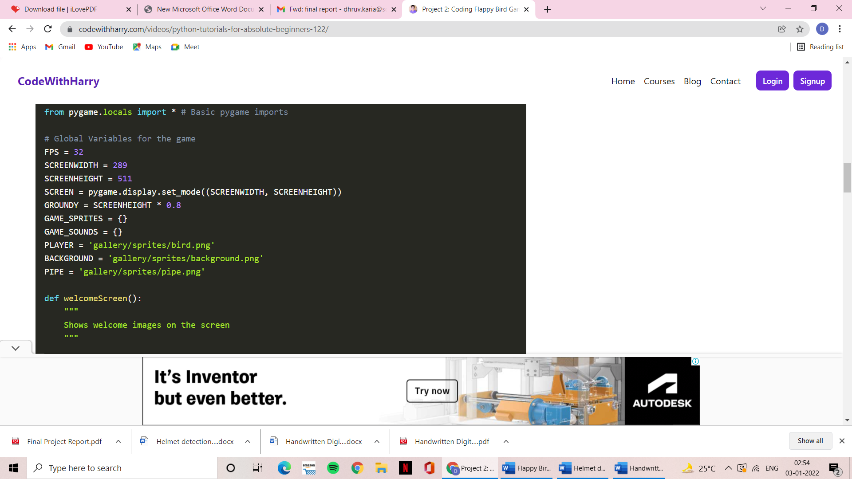

**Functioning of the game:**

1. **Welcome Screen:**

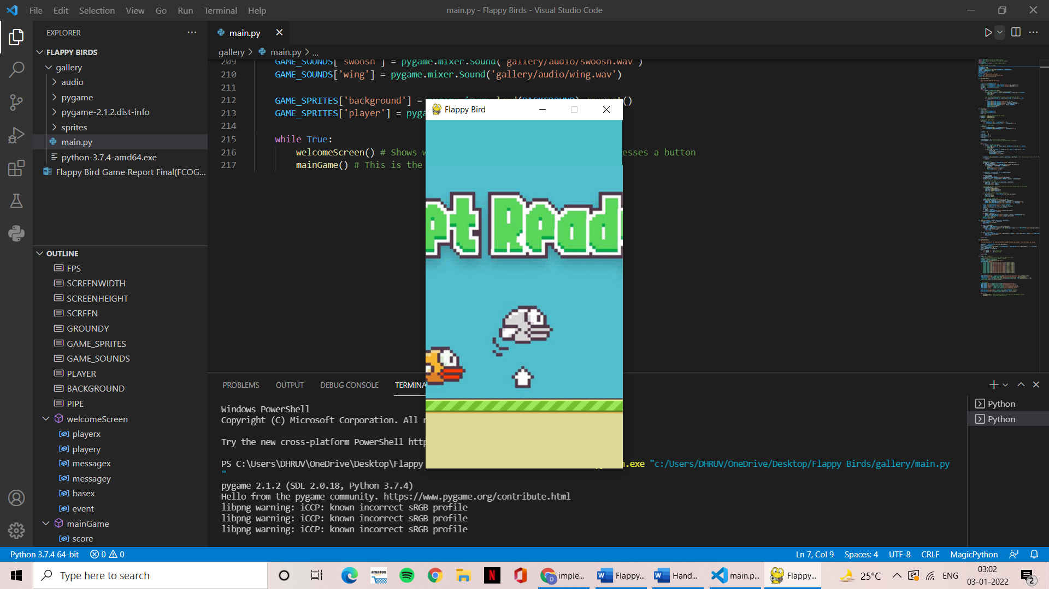

1. **In progress Game:**

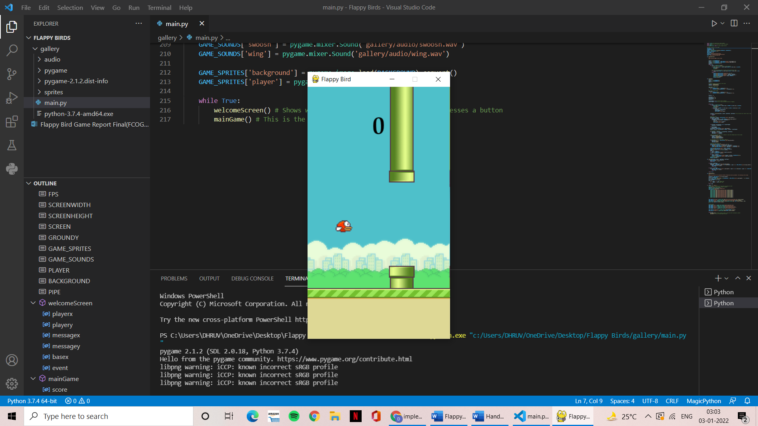

1. **Increasing score in the Background:**

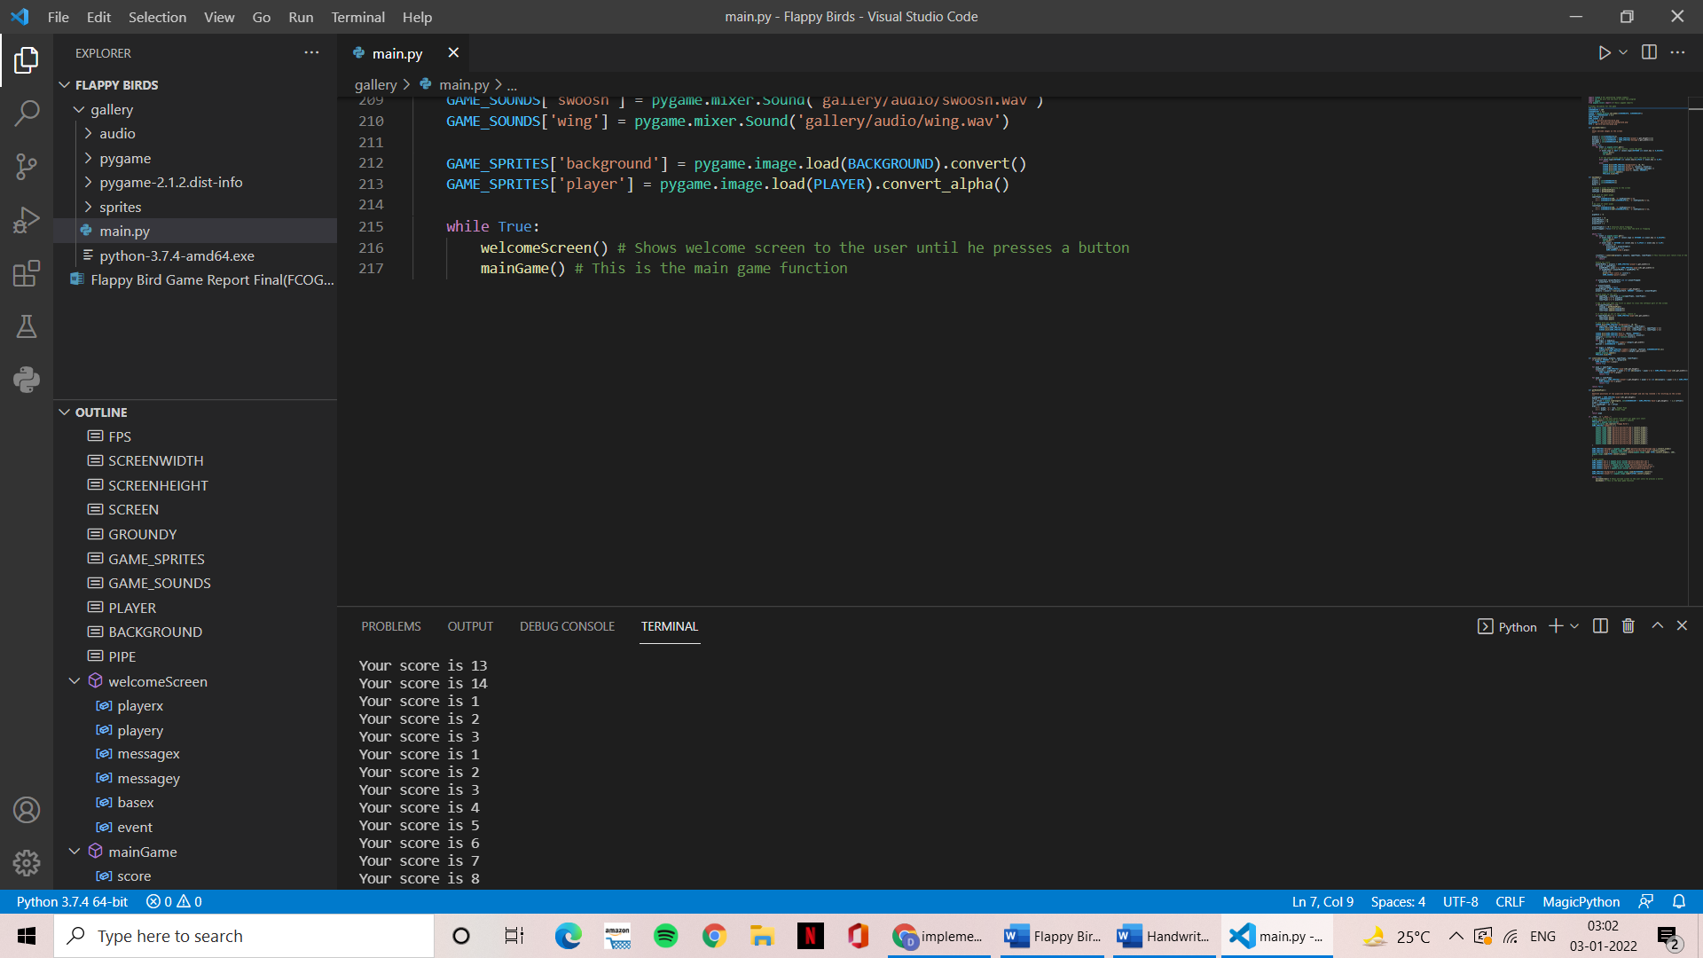

**Chapter 5**

**CONCLUSION**

**This chapter consists conclusion with advantages.**

**Conclusion:**

Our final project was planned, developed and demonstrated as expected. We designed a new version of “*Flappy Bird”* game with python, which could be played on any screen or personal computer. Each player will have a single life to create a new score and further progress in the game.

**Future Work:**

1. We will add more feature to the game and will change the bird and background scenery according to user choice. The status and the history will be saved and we show a graph where user can see his total performance whether it increasing or decreasing.
2. We can create the bird rotating effect when jumping or falling.

**References:**

1. **[Python reference](https://d.docs.live.net/daca239c70688150/Desktop/Flappy%20Birds/Flappy%20Bird%20Game%20Report%20Final(FCOG19117%5eJFCOG19150%5eJFCOG19107%5eJFCOG19109).docx)**
2. [**Pygame tutorials**](https://d.docs.live.net/daca239c70688150/Desktop/Flappy%20Birds/Flappy%20Bird%20Game%20Report%20Final(FCOG19117%5eJFCOG19150%5eJFCOG19107%5eJFCOG19109).docx)
3. [**Pygame documents**](https://d.docs.live.net/daca239c70688150/Desktop/Flappy%20Birds/Flappy%20Bird%20Game%20Report%20Final(FCOG19117%5eJFCOG19150%5eJFCOG19107%5eJFCOG19109).docx)

**Links:**

1. [**https://en.wikipedia.org/wiki/Flappy_Bird**](https://en.wikipedia.org/wiki/Flappy_Bird)
2. [**https://www.codewithharry.com/videos/python-tutorials-for-absolute-beginners-122/**](https://www.codewithharry.com/videos/python-tutorials-for-absolute-beginners-122/)
3. [**https://www.geeksforgeeks.org/how-to-make-flappy-bird-game-in-pygame/**](https://www.geeksforgeeks.org/how-to-make-flappy-bird-game-in-pygame/)